**Simplifying using Exponent Rules**

**Example.** Simplify the following expressions and write your answers without negative exponents:

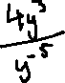

**Shortcut method:** negative exponent in numerator becomes a positive exponent in denominator. Negative exponent in denominator becomes a positive exponent in numerator.

**Example.** Simplify the expression and write your answer without negative exponents:

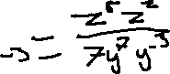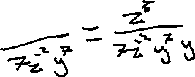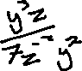

**Example.** Simplify the expression and write your answer without negative exponents:

